**COAL Lab no 4**

## 24k-0821 Jeevan Kumar

### Qno 1

Code:

include Irvine32.inc

.data

.code

main PROC

MOVE EBX,5h; Move is not a valid instruction, should be MOV

INC CX,5 ; INC only increaments a register by 1, if 5 has to be added we should use ADD

MOV 10H,AX; Immediate values cannot be destination operands, should be MOV AX,10H

MOV DX,DL; Both operands are of different sizes -> DX is 16-bit, DL is 8-bit

ADD 5, BX; Same issue as above, immediate values cannot be destination operands

MOV EAX 45d; Missing comma between operands, should be MOV EAX,45d

ADD 5,5; Both operands are immediate values, at least one operand must be a register or memory location to perform ADD operation

main ENDP

END main

Corrected code:

include Irvine32.inc

.data

.code

main PROC

MOV EBX, 5h

INC CX

MOV [10h], AX

MOV DL, DL

ADD BX, 5

MOV EAX, 45d

ADD BX, 5

main ENDP

END main

### Qno 3

Code:

include Irvine32.inc

.data

MSG1 BYTE "Hello first character :",0

msg2 byte "Hello second character : ",0

.code

main PROC

mov al,'j'

mov bl,'k'

mov edx , offset msg1

call writestring

movzx eax,al

call writedec

call crlf

mov edx,offset msg2

call writestring

movzx eax, bl

call writedec

call crlf

exit

main ENDP

END main

### Output:

Qno 3

Code:

include Irvine32.inc

.data

var1 BYTE 56

var2 word -300

var3 dword +500

.code

main PROC

movsx eax, var1

call WriteInt

call Crlf

movsx ebx , var2

mov eax , ebx

call WriteInt

call Crlf

mov ecx , var3

mov eax , ecx

call WriteInt

call Crlf

Exit

main ENDP

END main

Output:

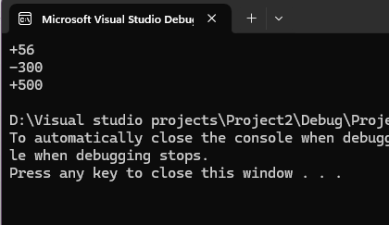

### Qno 4

i)

Code:

include Irvine32.inc

.data

var1 dword 15h

var2 byte 57o

var3 word 100d

.code

main PROC

mov eax,90

add eax , 65eh

sub eax,76o

sub eax ,45

add eax, 11010b

call WriteInt

call Crlf

exit

main ENDP

END main

Output:

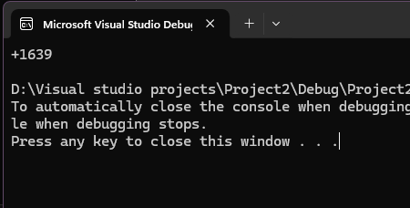

ii)

Code: include Irvine32.inc

.data

var1 dword 15h

var2 byte 57o

var3 word 100d

.code

main PROC

mov eax, var1

movzx ebx, var2

sub eax ,ebx

sub eax,64h

movzx ecx,var3

add eax,ecx

call WriteInt

call Crlf

exit

main ENDP

END main

Output:

Qno5

Code:

include Irvine32.inc

SecondsInADay equ 24*60*60

.data

msg byte "Seconds in a Day : ",0

.code

main PROC

mov edx, OFFSET msg

call WriteString

mov eax, SecondsInADay

call WriteInt

call Crlf

exit

main ENDP

END main

Output:

Qno 6

Code:

INCLUDE Irvine32.inc

.data

A WORD 0FF1Ah

B WORD 0EE0Ah

.code

main PROC

mov ax, A

mov bx, B

xchg ax, bx

mov A, ax

mov B, bx

movzx eax, A

call WriteHex

call Crlf

movzx eax, B

call WriteHex

call Crlf

exit

main ENDP

END main

Output:

Before exchanging :



After exchanging:



Qno 7

Code:

INCLUDE Irvine32.inc

.data

val1 BYTE 10h

val2 WORD 8000h

val3 DWORD 0FFFEh

val4 WORD 7FFEh

.code

main PROC

inc val2

movzx eax, val2

call WriteHex

call Crlf

movzx eax, val1

sub val3, eax

mov ax, val2

sub ax, val4

mov val2, ax

movzx eax, val2

call WriteHex

call Crlf

mov eax, val3

call WriteHex

call Crlf

exit

main ENDP

END main

Output:

